

Project Initialization and Planning Phase

Date | 30 September 2026
Team ID | SWTID-2026-7969
Project Name | Streamlining IT Procurement: Automating Standard Laptop Orders with Flow Designer
Maximum Marks | 3 Marks

Define Problem Statements (Customer Problem Statement Template):
Create a problem statement to understand your customer's point of view. The Customer Problem Statement template helps you focus on what matters to create experiences people will love. A well-articulated customer problem statement allows you and your team to find the ideal solution for your customers' challenges. Throughout the process, you’ll also be able to empathize with your customers, which helps you better understand how they perceive your product or service.

Example:
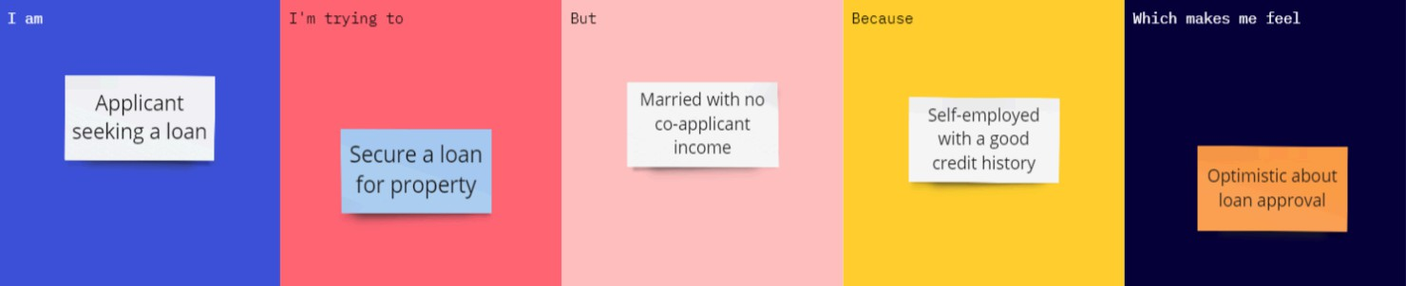

Define Problem Statements (Customer Problem Statement Template)

Problem Statement (PS) PDF | I am (Customer) PDF | I'm trying to PDF | But PDF | Because PDF | Which makes me feel PDF
PS-1 | New Hire / Employee | Request and receive a standard company laptop for my daily tasks quickly. | The approval and fulfillment process takes weeks with multiple manual emails and ticket handoffs. | IT procurement lacks an automated workflow and transparent tracking system. | Frustrated and unproductive during my initial onboarding phase.
PS-2 | IT Operations / Procurement Manager | Process hardware requests efficiently and track inventory accurately. | Manual verification, manager sign-offs, and vendor order creation are prone to delays and errors. | Request routing and approvals are handled manually across different platforms without a unified flow. | Overwhelmed by administrative overhead and unable to meet SLA targets.
PS-3 | Department Line Manager | Review and approve laptop requests for team members without delaying project timelines. | Approval requests get buried in overflowing email inboxes without clear budget context. | The current IT system lacks automated notification and quick-approval mechanisms (like Flow Designer triggers). | Anxious about missing deadlines and slowing down team productivity.

